09 – Dictionary

Dept of Artificial Intelligence and Machine Learning | Rajalakshmi Engineering College

. 117

vEx. No. : 9.1 Date: 4/5/24

Register No.: 231501058 Name: M Harish

Uncommon words

A sentence is a string of single-space separated words where each word consists only of lowercase letters.A word is uncommon if it appears exactly once in one of the sentences, and does not appear in the other sentence.

Given two sentences s1 and s2, return a list of all the uncommon words. You may return the answer in any order.

PROGRAM

s1 = input()

s2 = input()

words1 = s1.split()

words2 = s2.split()

count = {}

for word in words1 + words2:

if word in count:

count[word] += 1

else:

count[word] = 1

uncommon_words = [word for word in count if count[word] == 1]

print(uncommon_words)

Dept of Artificial Intelligence and Machine Learning | Rajalakshmi Engineering College

. 118

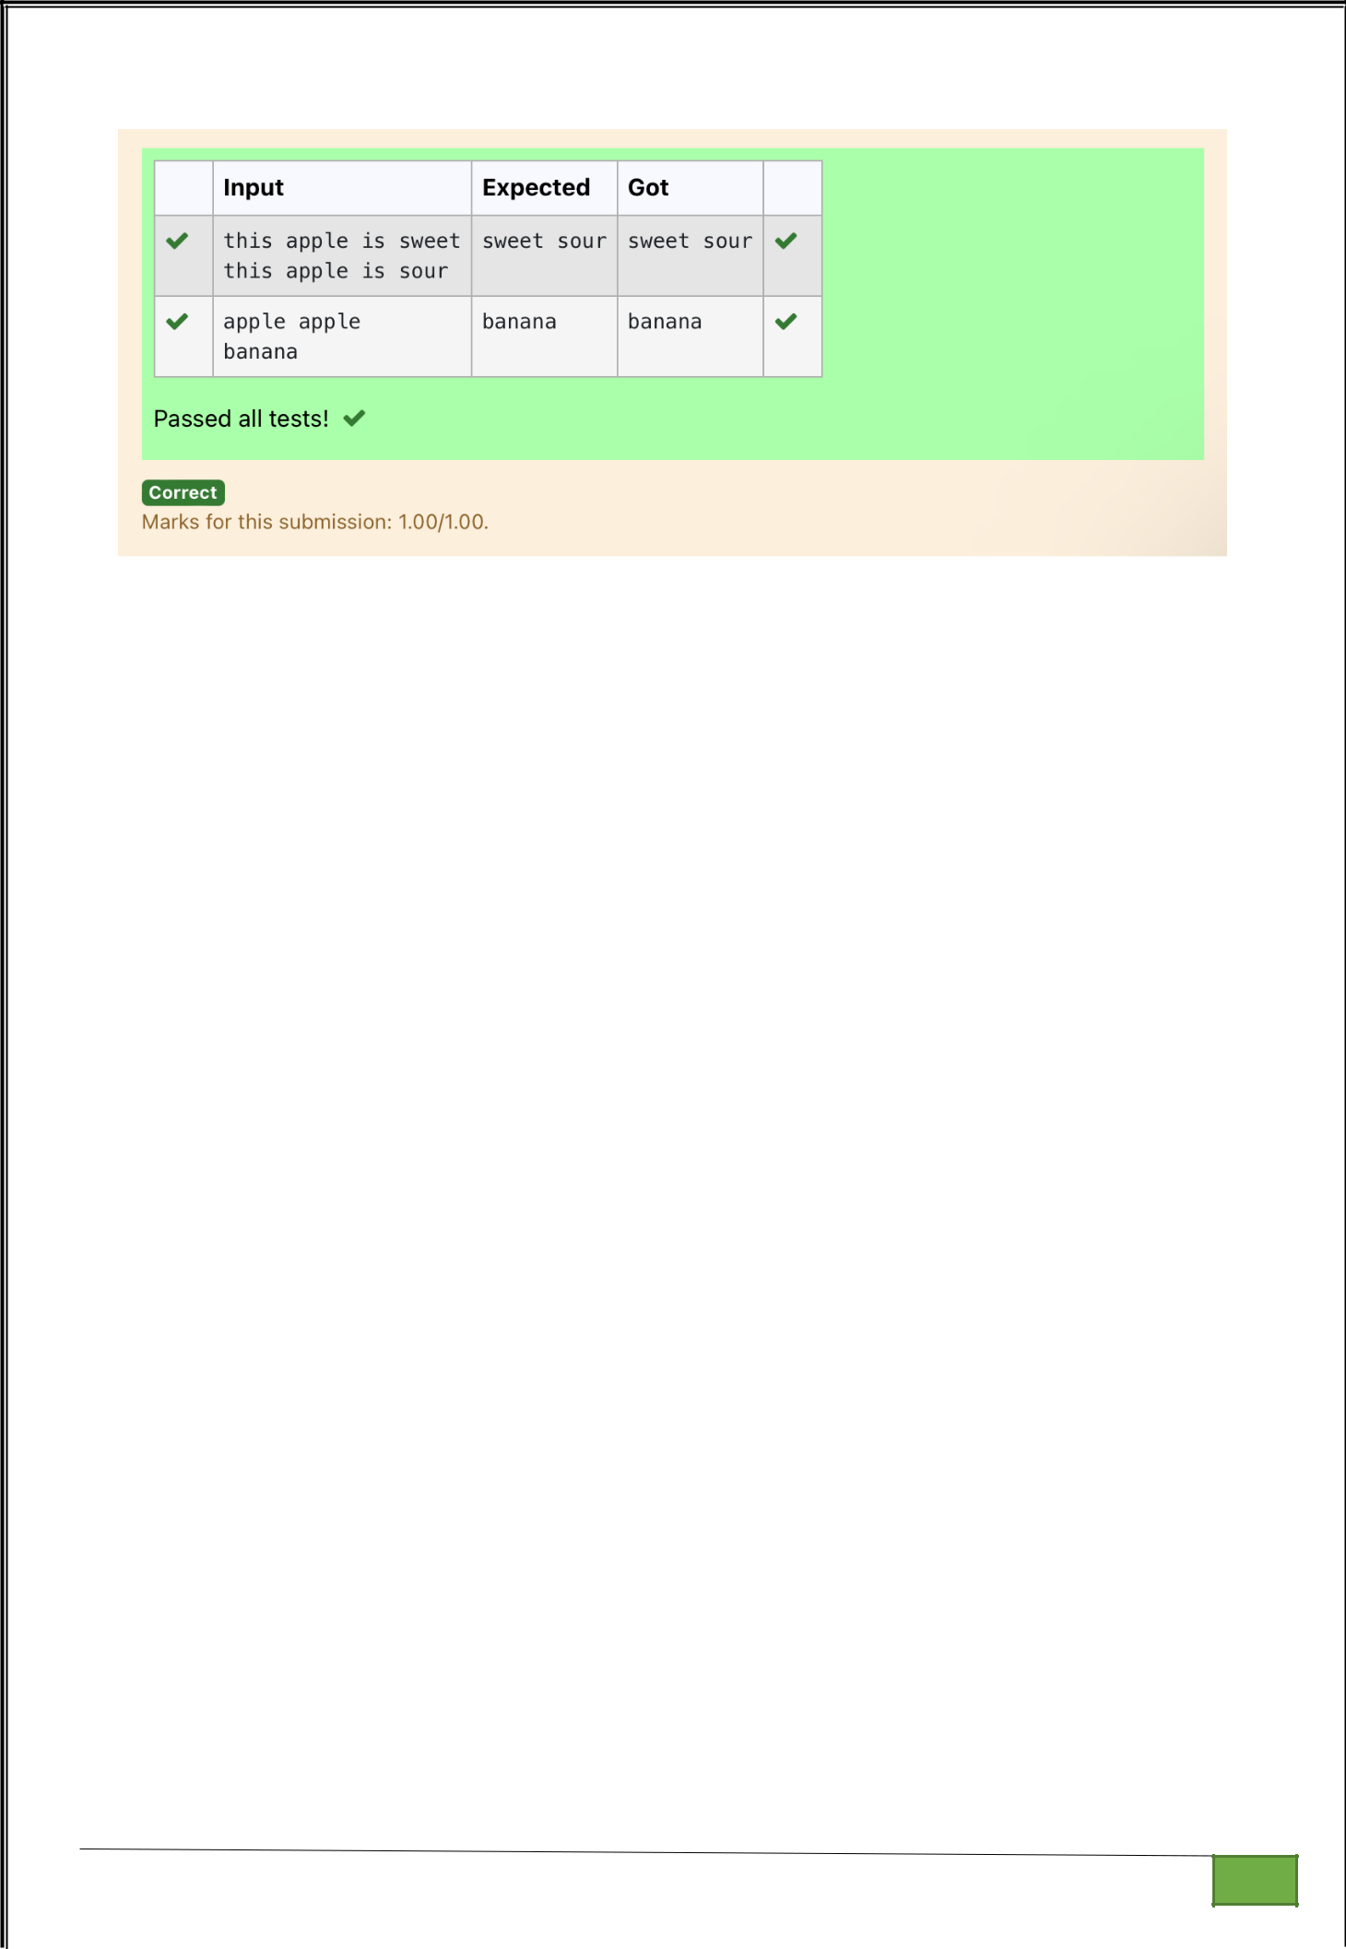

Dept of Artificial Intelligence and Machine Learning | Rajalakshmi Engineering College

. 119

Ex. No. : 9.2 Date: 4/5/24

Register No.: 231501058 Name: M Harish

Sort Dictionary by Values Summation

Give a dictionary with value lists, sort the keys by summation of values in value list.

Input : test_dict = {‘Gfg’ : [6, 7, 4], ‘best’ : [7, 6, 5]}

Output : {‘Gfg’: 17, ‘best’: 18}

Explanation : Sorted by sum, and replaced.

Input : test_dict = {‘Gfg’ : [8,8], ‘best’ : [5,5]}

Output : {‘best’: 10, ‘Gfg’: 16}

Explanation : Sorted by sum, and replaced.

Sample Input:

2

Gfg 6 7 4

Best 7 6 5

Sample Output

Gfg 17

Best 18

For example:

Input | Result

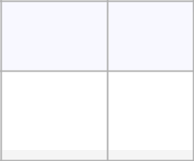

 | 2 |  |  |  | Gfg 17
 | Gfg 6 7 4 |  |  |  | Best 18
 | Best 7 6 5

PROGRAM

n=int(input())

l1=[]

l2=[]

l3=[]

d=dict()

for i in range(n):

l1=input().split(" ")

l2.append(l1[0])

l1.pop(0)

l3.append(l1)

for j in range(len(l3)):

sum=0

for k in l3[j]:

sum+=int(k)

l3[j]=sum

for i in range(len(l2)):

d[l2[i]]=l3[i]

dn=dict(sorted(d.items(),key=lambda items:items[1]))

for key,value in dn.items():

print(f"{key} {value}")

Dept of Artificial Intelligence and Machine Learning | Rajalakshmi Engineering College

. 120

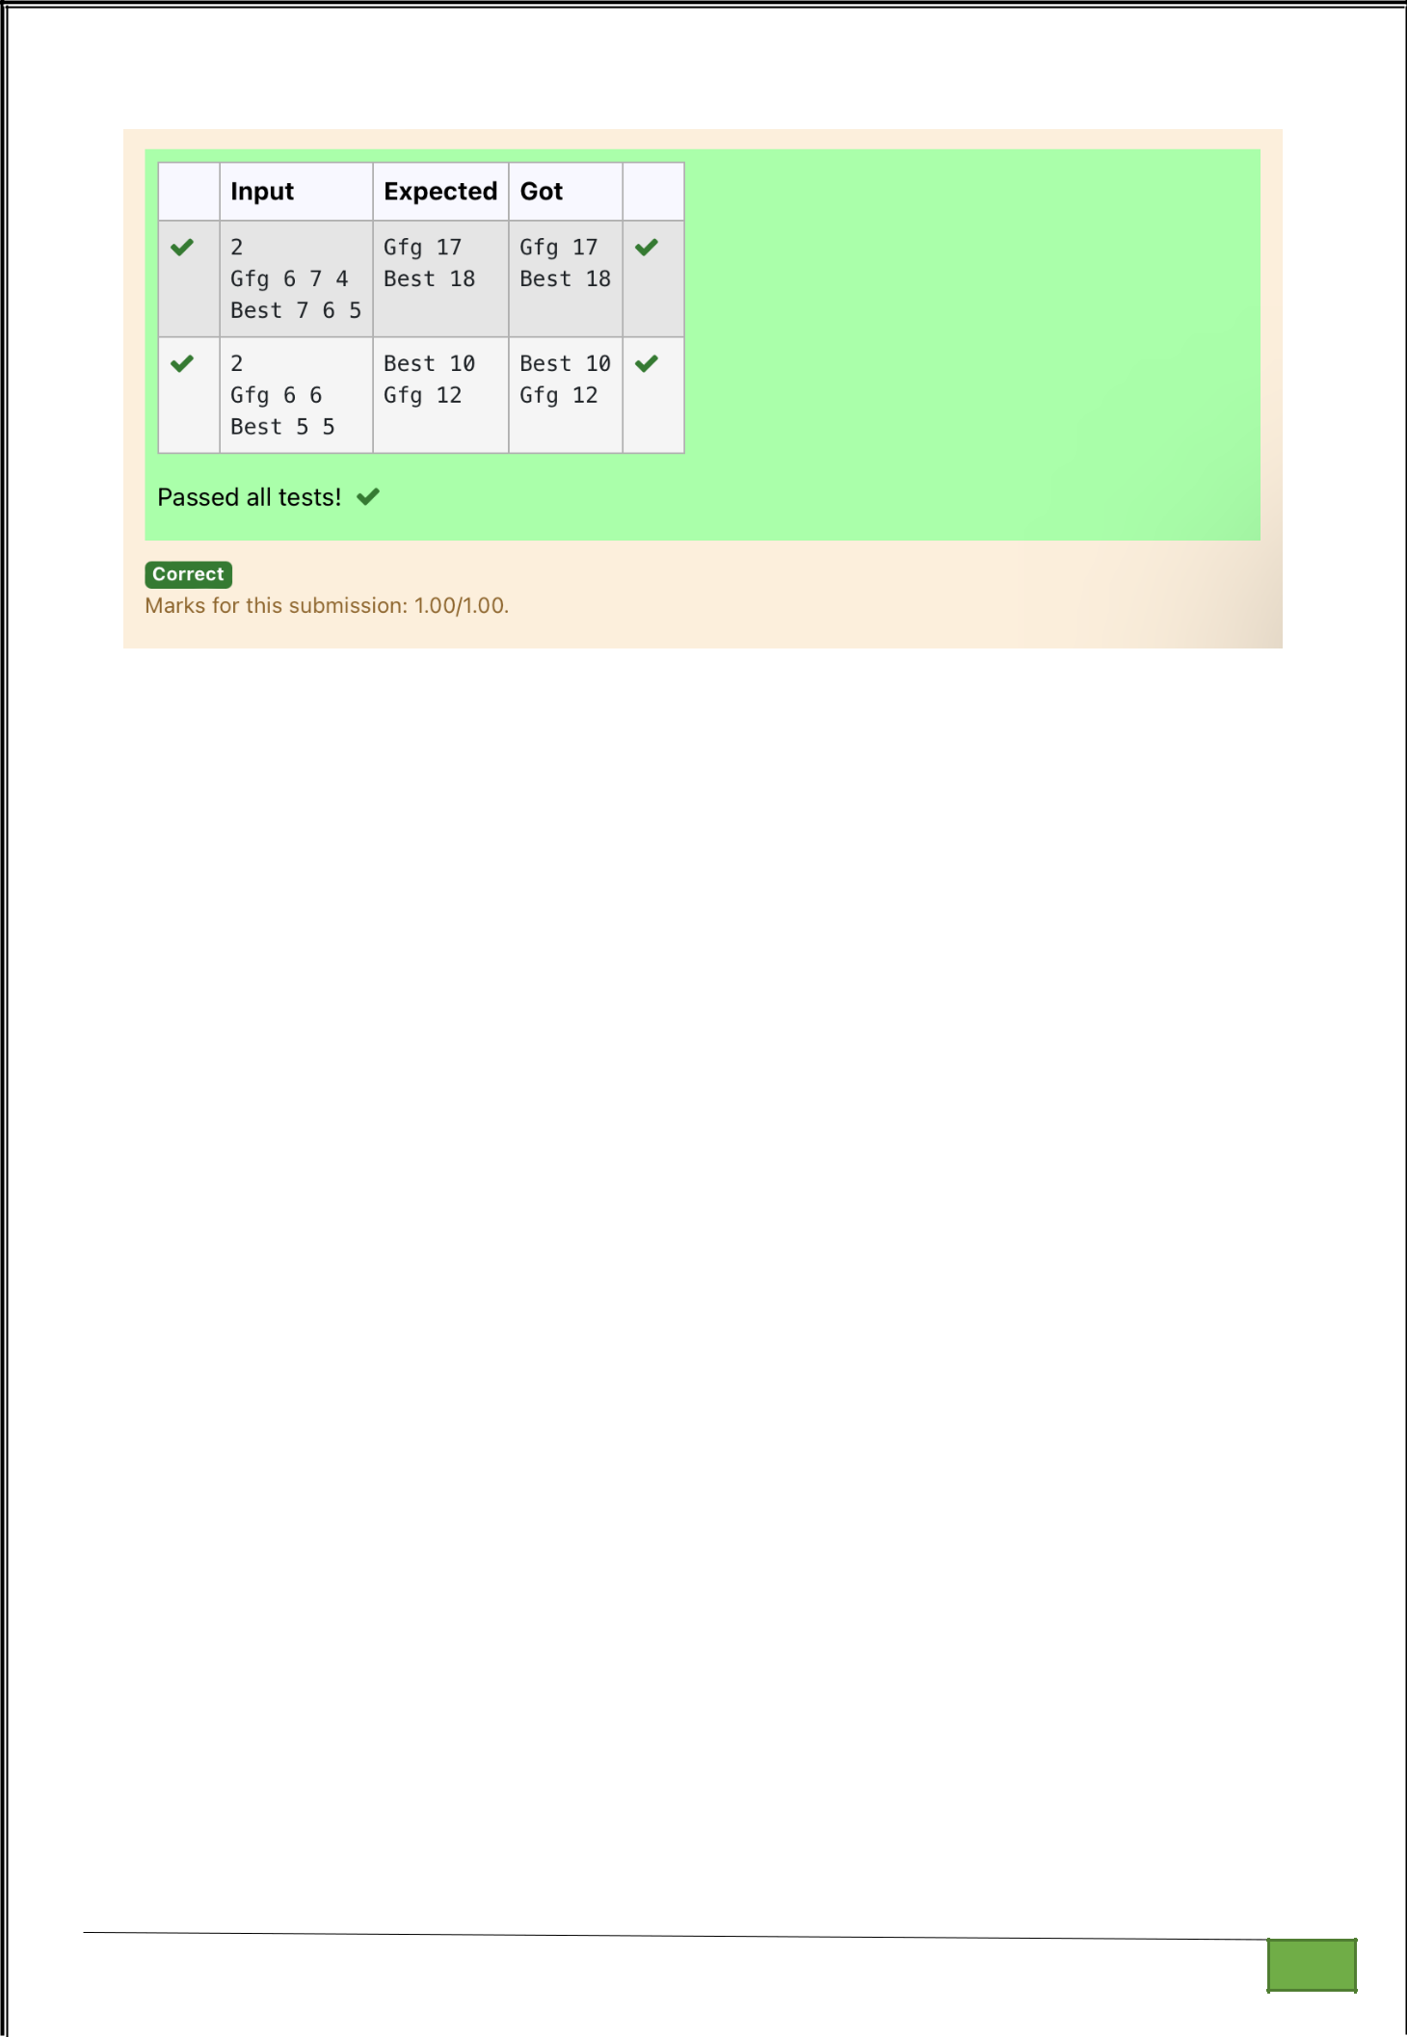

Dept of Artificial Intelligence and Machine Learning | Rajalakshmi Engineering College

. 121

Ex. No. : 9.3 Date: 4/5/24

Register No.: 231501058 Name: M Harish

Winner of Election

Given an array of names of candidates in an election. A candidate name in the array represents a vote cast to the candidate. Print the name of candidates received Max vote. If there is tie, print a lexicographically smaller name.

Examples:
Input : votes[] = {"john", "johnny", "jackie",

"johnny", "john", "jackie",
"jamie", "jamie", "john",
"johnny", "jamie", "johnny",
"john"};
Output : John

We have four Candidates with name as 'John', 'Johnny', 'jamie', 'jackie'. The candidates John and Johny get maximum votes. Since John is alphabetically smaller, we print it. Use dictionary to solve the above problem

Sample Input:

10
John
John
Johny

Jamie
Jamie
Johny
Jack
Johny

Johny
Jackie

Sample Output:
Johny

Dept of Artificial Intelligence and Machine Learning | Rajalakshmi Engineering College

. 122

For example:
Input | Result
10 | Johny
John
John
Johny
Jamie
Jamie
Johny
Jack
Johny
Johny
Jackie

PROGRAM

n=int(input())

l1=[]

d=dict()

for i in range(n):

l1.append(input())

for j in l1:

d[j]=l1.count(j)

n1=max(d)

m=d[n1]

d.pop(n1)

n2=max(d)

if(m== d[n2]):

if(len(n1)<len(n2)):

print(n1)

else:

print(n2)

else:

print(n1)

Dept of Artificial Intelligence and Machine Learning | Rajalakshmi Engineering College | . 123

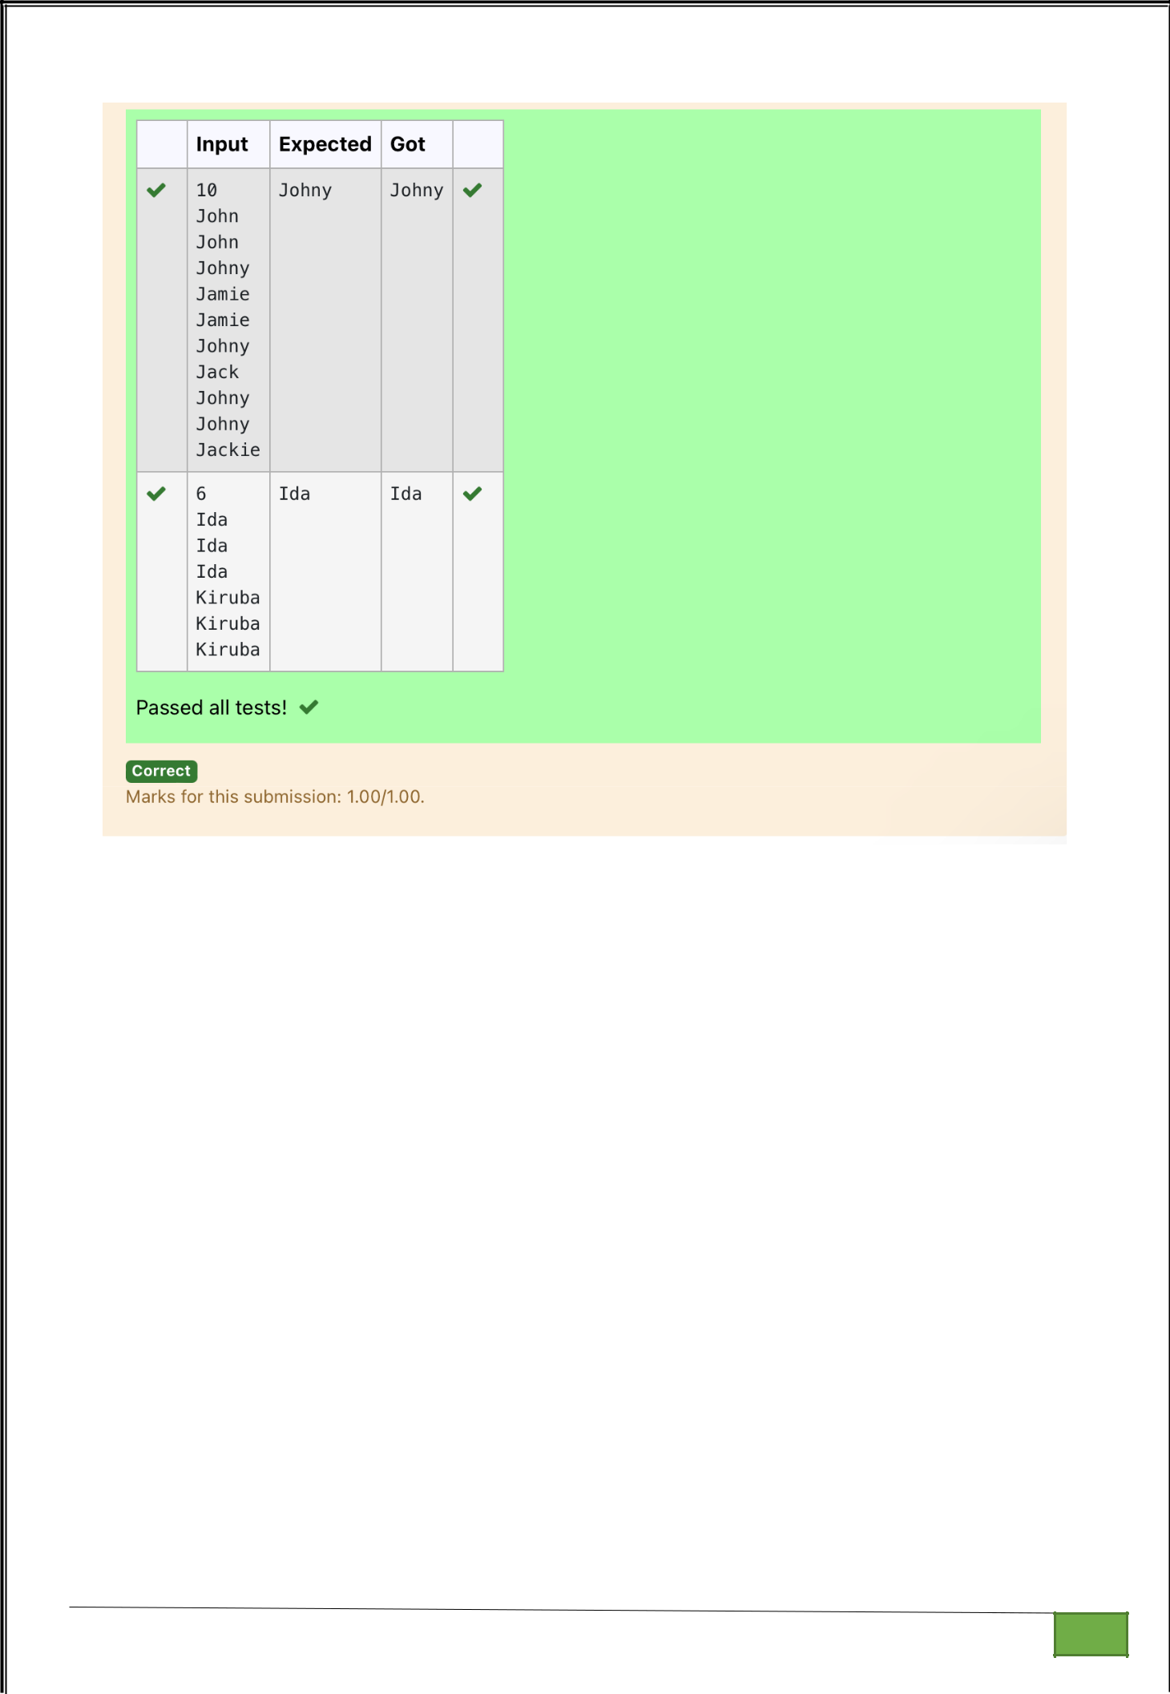

Dept of Artificial Intelligence and Machine Learning | Rajalakshmi Engineering College

. 124

Ex. No.

:
9.4
Date: 4/5/24

Register No.: 231501058

Name: M Harish

Student Record

Create a student dictionary for n students with the student name as key and their test mark assignment mark and lab mark as values. Do the following computations and display the result.
1.Identify the student with the highest average score
2.Identify the student who as the highest Assignment marks

3.Identify the student with the Lowest lab marks
4.Identify the student with the lowest average score
Note:
If more than one student has the same score display all the student names

Sample input:

4

James 67 89 56

Lalith 89 45 45

Ram 89 89 89

Sita 70 70 70

Sample Output:

Ram

James Ram

Lalith

Lalith

PROGRAM

n=int(input())

list1=[]

list2=[]

list3=[]

list4=[]

list5=[]

for i in range(n):

student_data=input()

student_input_parts=student_data.split()

name=student_input_parts[0]

marks=[int(mark) for mark in student_input_parts[1:]]

average=(marks[0]+marks[1]+marks[2])/3

list1.append(name)

list2.append(marks[0])

list3.append(marks[1])

list4.append(marks[2])

list5.append(average)

l1=[]

Dept of Artificial Intelligence and Machine Learning | Rajalakshmi Engineering College | . 125

for i in range(n):

if list5[i]==max(list5):

l1.append(list1[i])

for i in l1:

print(i,end=' ')

print()

l2=[]

for i in range(n):

if list3[i]==max(list3):

l2.append(list1[i])

for i in l2:

print(i,end=' ')

print()

l3=[]

for i in range(n):

if list4[i]==min(list4):

l3.append(list1[i])

l3.reverse()

for i in l3:

print(i,end=' ')

print()

l4=[]

for i in range(n):

if list5[i]==min(list5):

l4.append(list1[i])

for i in l4:

print(i,end=' ')

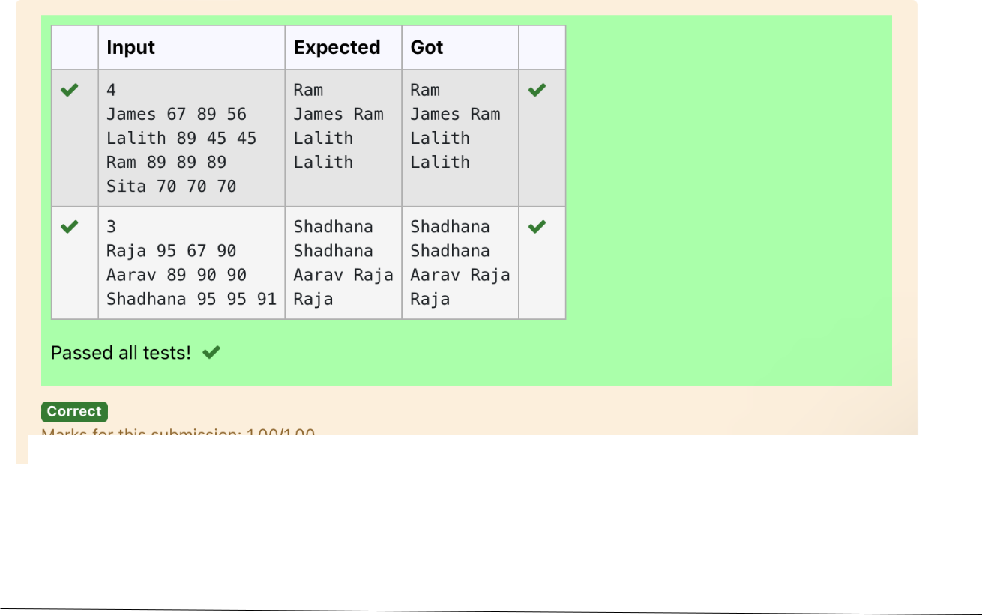

Dept of Artificial Intelligence and Machine Learning | Rajalakshmi Engineering College | . 126

Ex. No. : 9.5 Date: 4/5/24

Register No.: 231501058 Name: M Harish

Scramble Score

In the game of Scrabble™, each letter has points associated with it. The total score of a word is the sum of the scores of its letters. More common letters are worth fewer points while less common letters are worth more points.

Write a program that computes and displays the Scrabble™ score for a word. Create a dictionary that maps from letters to point values. Then use the dictionary to compute the score.

A Scrabble™ board includes some squares that multiply the value of a letter or the value of an entire word. We will ignore these squares in this exercise.

The points associated with each letter are shown below:

Points Letters

1 A, E, I, L, N, O, R, S, T and U

2 D and G

3 B, C, M and P

4 F, H, V, W and Y

5 K

8 J and X

10 Q and Z

Sample Input

REC

Sample Output

REC is worth 5 points.

PROGRAM

s=input()

l1=list(s)

d=dict([(1,['A','E','I','L','N','O','R','S','T','U']),(2,['D','G']),(3,['B','C ','M','P']),(4,['F','H','V','W','Y']),(5,['K']),(8,['J','X']),(10,['Q','Z'])]) sum=0

for j in l1:

for key,values in d.items():

if j in values:

sum+=key

print(f"{s} is worth {sum} points.")

Dept of Artificial Intelligence and Machine Learning | Rajalakshmi Engineering College

. 127

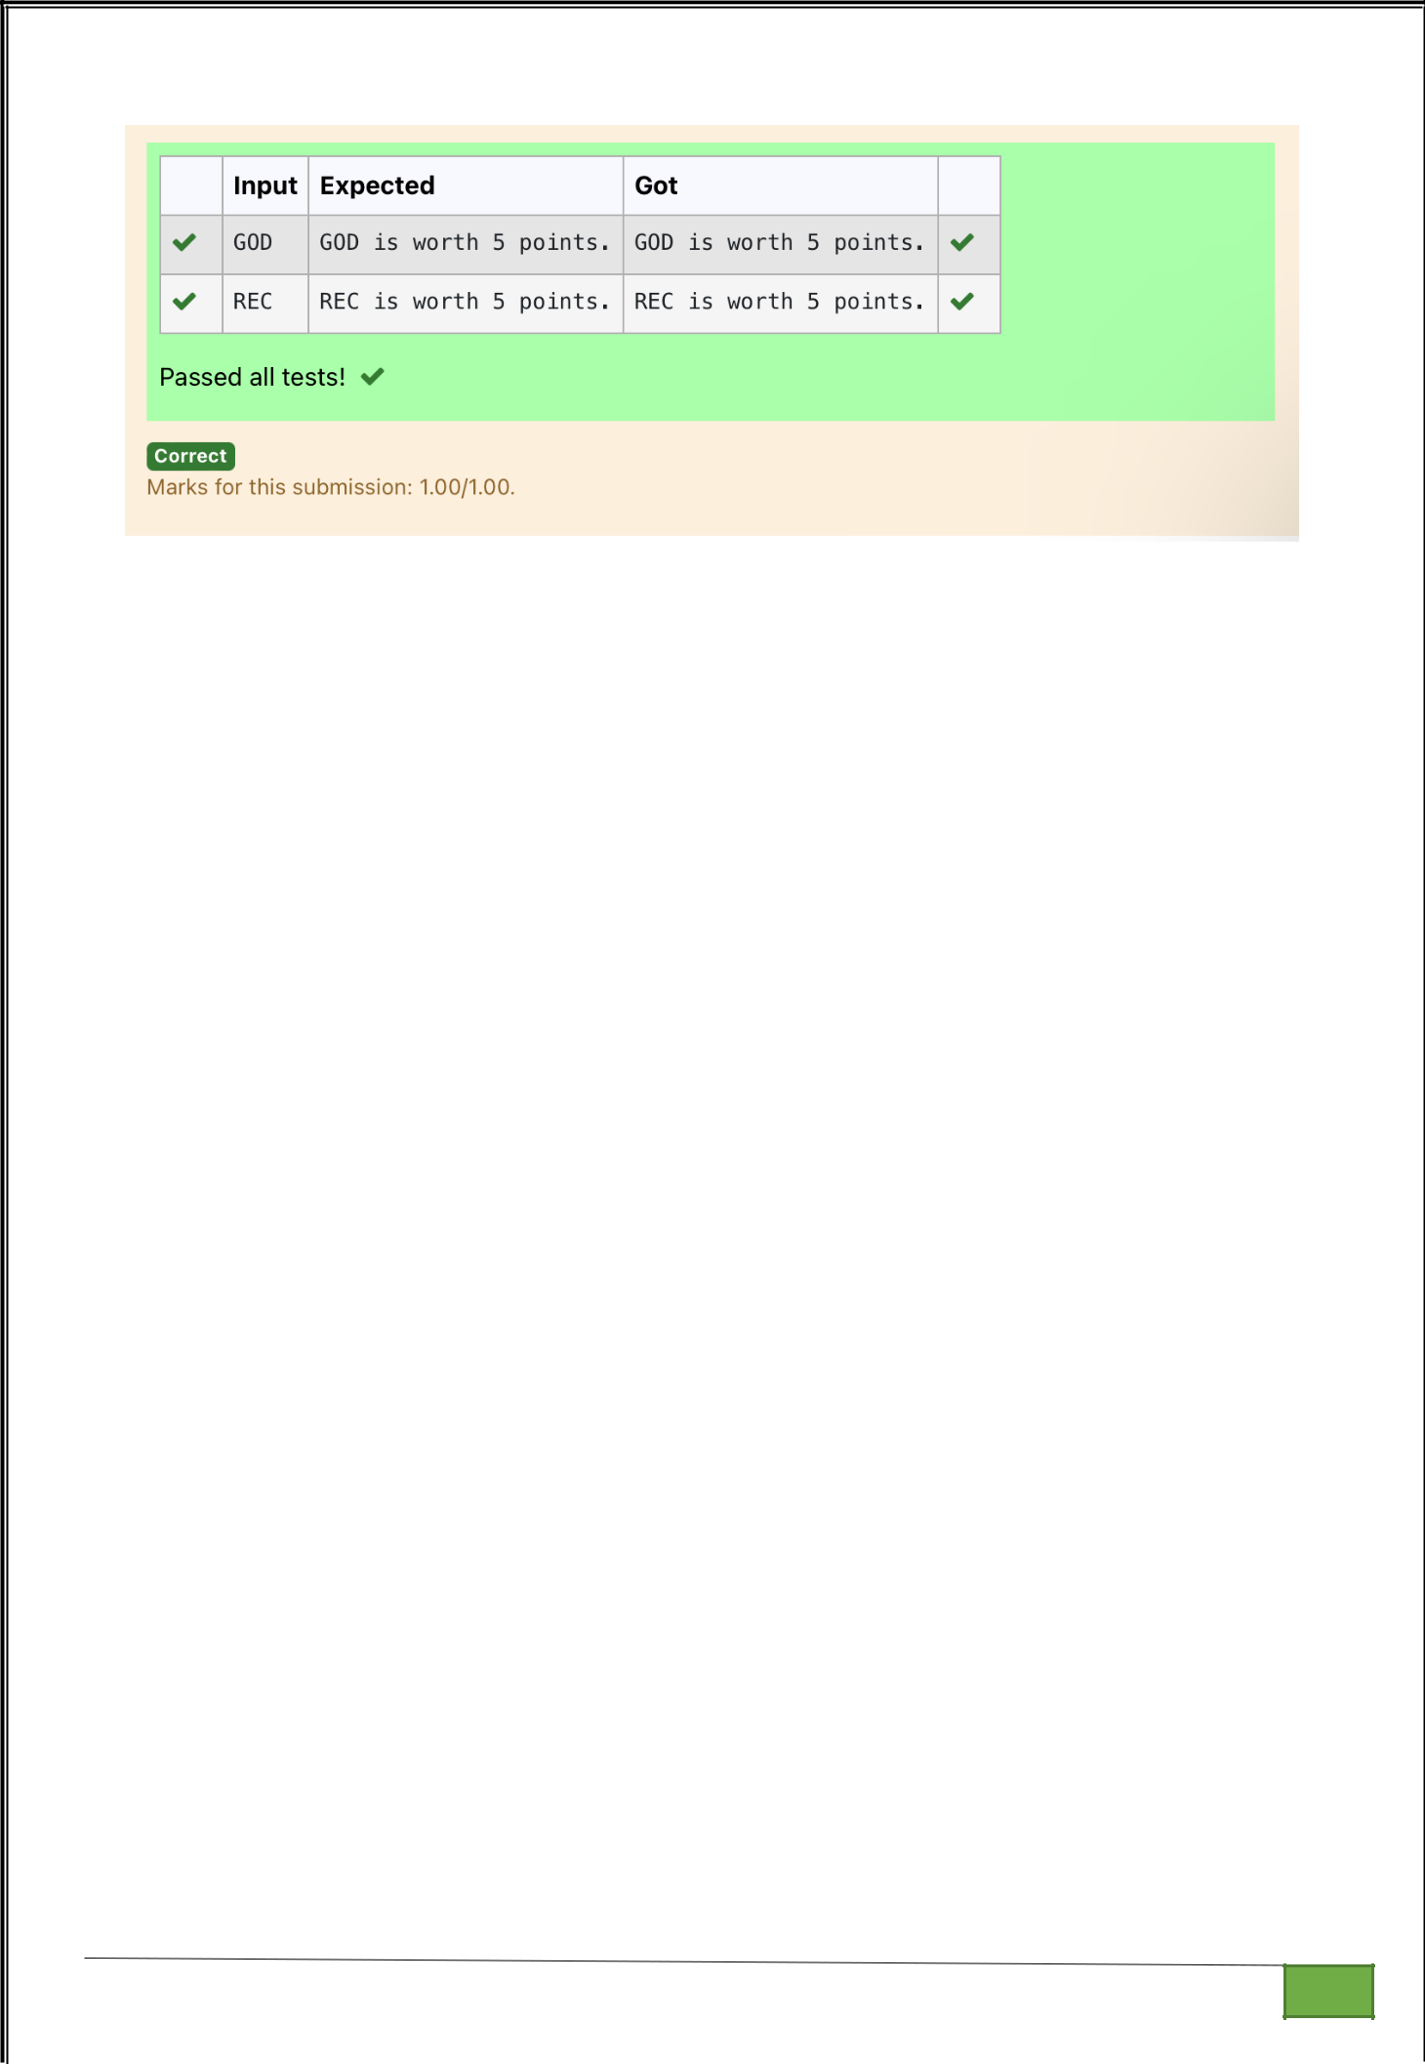

Dept of Artificial Intelligence and Machine Learning | Rajalakshmi Engineering College

. 128

